Les secrets d’un estomac plat
Avoir un estomac plat est un rêve de beaucoup de personnes, sportives ou non. Découvrez les spécificités et techniques pour l’obtenir.
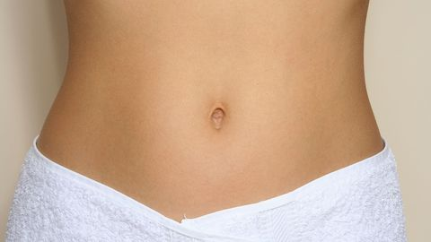
Introduction:
Pour les personnes – sportives ou non – un estomac plat est un synonyme non seulement de beauté, mais surtout de bonne forme et santé. Il montre non seulement une absence de dépôts de tissus adipeux, mais également un système digestif en bonne santé, absence de problèmes de drainage, absence de bactéries.... Pour obtenir un estomac plat, il est une alimentation équilibrée et saine n’est pas le seul facteur à concidérer – il y a aussi les exercices physiques, les facteurs individuels digestifs, la morphologie de départ qui entrent en jeu.

Les techniques pour l’obtenir Purpose: Bust the myths around getting six pack abs and explain why and how can flat stomach can be reached in 8+1 steps (find them bellow).

Meta description (max 160 characters):

Minimum word count: 800
Maximum word count: 1100

Additional Keywords (ENG): secret, flat stomach, belly, eating, lifestyle, food, reach, tips, diet, weight loss, best, exercises, healthy, proper,

Note:
- The main keyword is included in the H1 and at least once in H2, in addition minimum once in the text.
- Suggested additional keywords should be included in the text at least 1 time.
- The title of the article should be up to 64 characters long.
- The meta description should be up to 160 characters long.

Suggested titles (includes the main keyword up to 64 characters):

- The secret of flat stomach
- 8+1 tips to get flat stomach
- The 8 best ways to get flat stomach

Content:

Introduction:

Introduction of the topic in minimum of 100 words, answering the following questions:
- Why is it hard to get flat belly/stomach?
- How does this article help?

What are the parts of your abs? (H2)
This paragraph introduces in minimum of 100 words the anatomy of abdominal muscles and their function, answering these questions:
- What are the four parts of ab muscles and how can it be improved?
- How visceral and belly fat effect on 6 pack abs?

Useful resource:
https://www.betterhealth.vic.gov.au/health/conditionsandtreatments/abdominal-muscles

Common myths about how to train abs (H2)
In this paragraph explain in minimum of 150 words what are the most common myths and facts about the proper way to improve your ab muscles, reacting these points:
- Doing ab exercises gets rid of abdominal fat
- Doing ab workout every day helps to get 6 pack
- The same workout plan is good for beginners and advanced

Useful resource:
https://www.verywellfit.com/myths-about-your-abs-1229499

The secret of flat stomach in 8+1 steps (H2)
In this paragraph explain in minimum of 50-50 words how the following 8+1 steps help in flat abs:
- Cut calories - eat less carbohydrates
- Avoid salt, sugar and alcohol
- Drink a lot of water
- Do more cardio workout
- Do resistance training like TRX, CrossFit, Gflex, etc.
- Drink protein shakes
- Vary your abs workout routine
- Always have breakfast
+1 Use supplements to help fat burning (with examples)

Useful resource:
https://www.healthline.com/nutrition/get-a-flat-stomach

